**SUSPENSION SUPPORT**

# Aims

* Guarantee the contact between the tires and the road permanently.
* Tune the car’s handling

# Conception steps

Step 1: Wheel rate calculation

Ride frequency chosen and the wheel rate based on it:

|  |  |  |
| --- | --- | --- |
|  | Front | Rear |
| Ride frequency (Hz) | 1.78 | 1.67 |
| Wheel rate (N/mm) | 36.4 | 32.2 |

Step 2: Determination of the geometry

Reminder: The motion ratio is defined as:

$$MR=\frac{Wheel travel}{Spring travel}$$

Hence, we have:

$$MR^{2}=\frac{Spring rate}{Wheel rate}$$

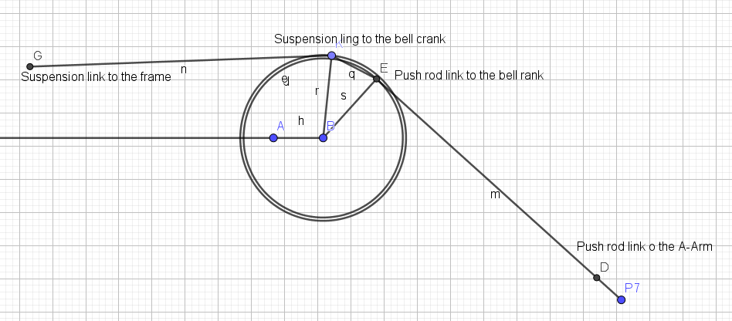The goal of the geometry was to aim **a linear descending motion ratio** with a value of **1.1 in static**. To reach this value, 2D model were used thanks to Geogebra.

Figure 1: 2D model to determine rear suspension geometry

# 

Figure 2: 2D model to determine front suspension geometry

This lead to the following Motion Ratio curves:

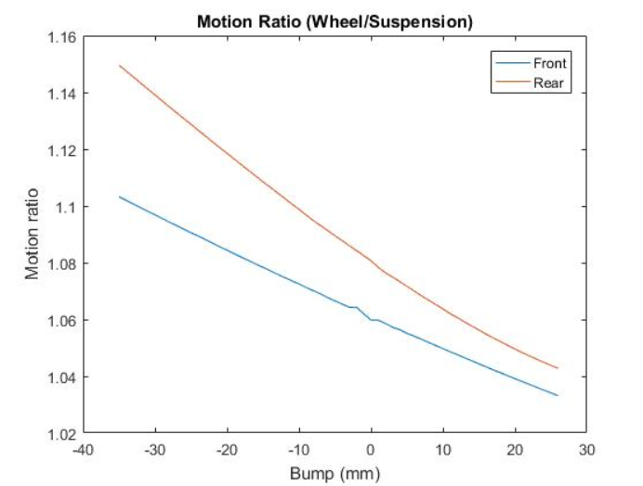

Figure 3: Motion ratios of the car

Figure 1: 3D timing advance map

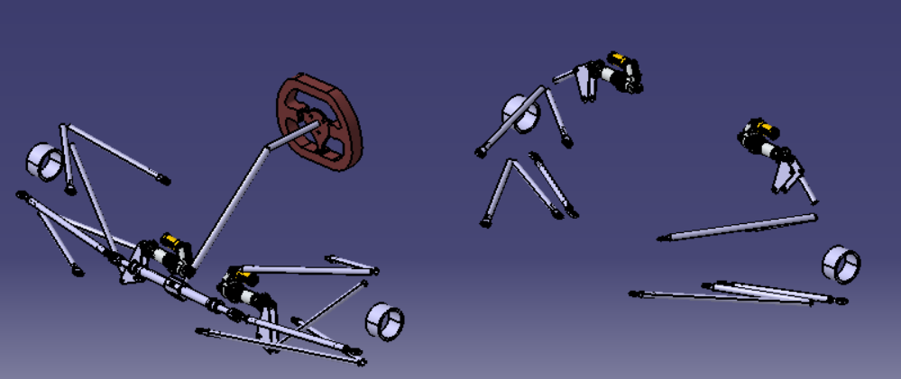

Figure 4: 3D model used to confirm the motion ratio curves